ScentTech Analytics : Uncovering fragrance categories through Machine Learning Clustering
ScentTech Analytics is a firm operating in the competitive fragrance industry, pointing to leverage data to enhance its market position. The purpose of this project is to support SentTech by analyzing the dataset to found hidden customer and product segments.
The primary goal of this analysis is to develop and evaluate several unsupervised clustering models. Grouping fragrances based on attributes like brand,price sales volume,and location.
Data loading and exploration:
Library imports:
At first we will import the important libraries.
Pandas: used for loading, manipulating and analyzing
numpy: Provides numerical computations and array operations
StandardScaler: Scales features to have 0 mean.
Matplotlib.pyplot:used for creating visulizatons
Kmeans: For kmean clustering(sklearn.cluster)
Initial data loading:
The dataset was loaded into pandas dataframe and an initial inspection with df.head() which revealed us the data structure and showing 10 columns.
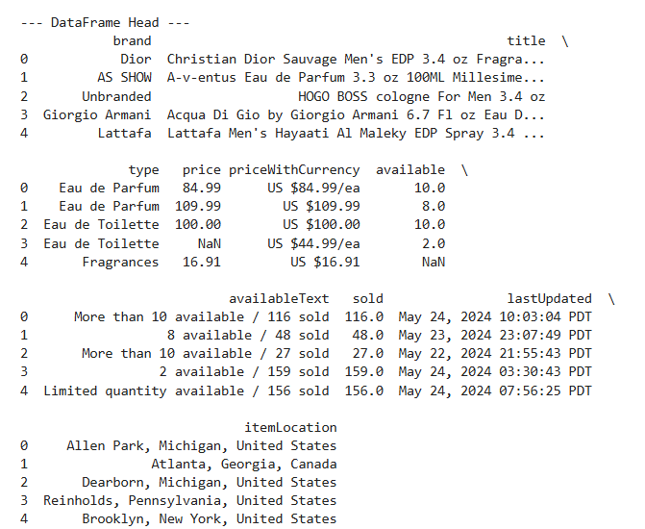
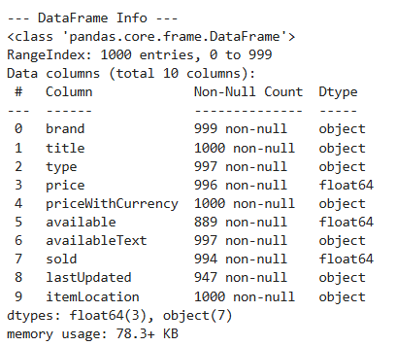
Data Processing:
In data processing we will prepare the fragrance dataset so it can be used for clustering because clustering needs clean dataset.
1. We removed the rows with missing values using df=df.dropna() because missing values breaks the machine learning algorithms.
2. Then we handle the outliers in price and sold.
3. Then we scaled the numeric features where it changes all numeric values to have mean equal to 0 and standard deviation 1 because clustering needs features on similar scale.
4. Then we converted the text columns into numbers by turning categories into numeric codes because machine learning cannot read text.
5.Then we removed the irrelevant columns that are not useful for clustering such as columns that contains log text.
Before and after comparison:
Before processing: The dataset have missing values, text fields and inconsistent numeric scales.
After processing: All rows with missing data were removed and making the dataset clean.
Feature selection and justification:
For the clustering the feature choses price, availability, sold, brand, type, and itemloaction. These variables represent key product that’s why they are chosen and also represent market attributes that directly influence customer behavior .
How these features matters:
Price is a fundamental indicator of product positioning and it helps distinguish brands.
Available represent supply levels and seller strategy.
Sold is a strong demand signal that identifies popular or high performing.
Brand is a categorical variable that captures brand reputation.
Type represents product classification.
Itemloaction shows geographical selling location which can influence pricing and availability.
This combination allows the models to find segments based not just on what is,but how it performs in the market and where it sold.
Applying multiple clustering methods:
K-Means:
k-means(k=4) found four meaningfull clusters that differ mostly by sales volume and availability with moderate price difference between clusters. For example, one cluster contains the highest sellers with large availability likely best for selling and high-turnover. While other clusters contains lower selling items.The silhouette score indicates clusters are present but not extremely tight.
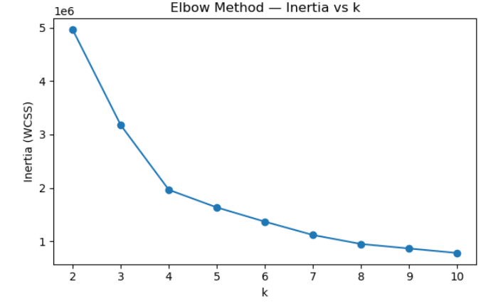

The Elbow plot displays how the inertia with cluster sum of square changes as the number of clusters k increases. Inertia decreases as k increases, but after a certain point the improvement becomes small.
The goal was to identify where the curve starts to flatten as at that point indicates that adding more clusters does not significantly improve the model.
The elbow begins to form around k=4 meaning four clusters provide a reasonable trade off between accuracy and simplicity.
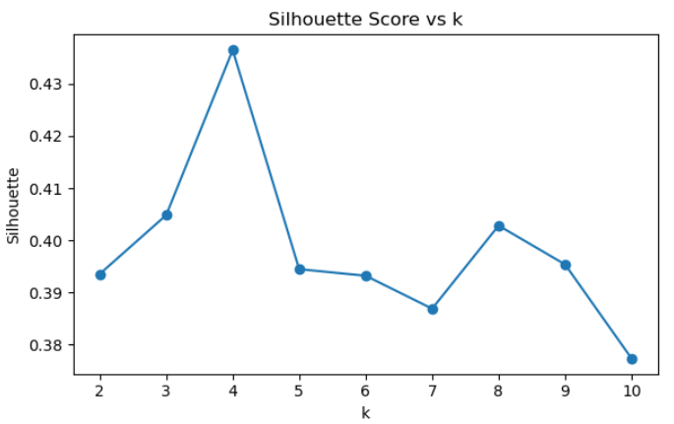
The plot displays the silhouette score for each value of k. Silhouette measures how well separated and cohesive the clusters are.
Higher score indicates better defined clusters. The peak value suggests the best performing number of clusters.
The highest Sihouette score occurred at k=4 confirming that four clusters give the strongest and clearest separation.
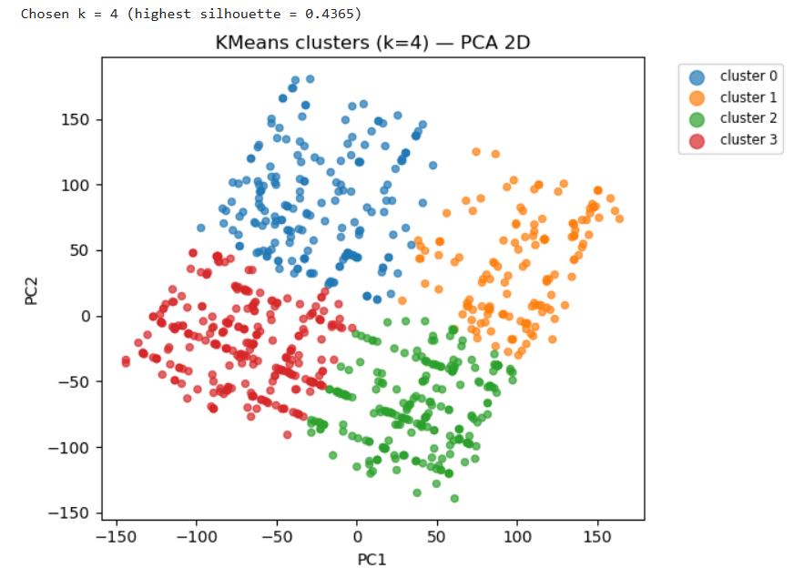
A 2d visualization of the k-mean clusters using PCA, where each point represents a perfume listing and each color corresponds to a clusters .
PCA compares the original features into two components to make clusters easier to see. Well separated colors indicated strong clustering.
Four noticeable colour groups appear, meaning k-means successfully identified four useful clusters. Some overlap exists which matches the moderate silhouette(~0.44),but overall cluster separation is clear.
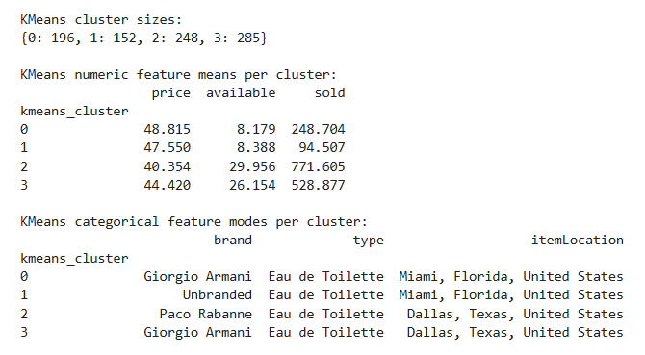
Clusters separated mostly by sales SOLD and availability, with price difference also present where cluster 0 has highest sold and availability and cluster three the lowest sold.

DBSCAN:
The plot shows the shortest distance to the kth nearest neighbor for each point. It helps estimate the best eps value for DBSCAN.
A sharp rise near the end of the curve indicated the threshold where points become isolated. It uses this to decide cluster density.
The curve rises towards the end and the automated method selected the 90th percentile giving eps=25.95. This relatively high value leads to DBSCAN forming a single large cluster.
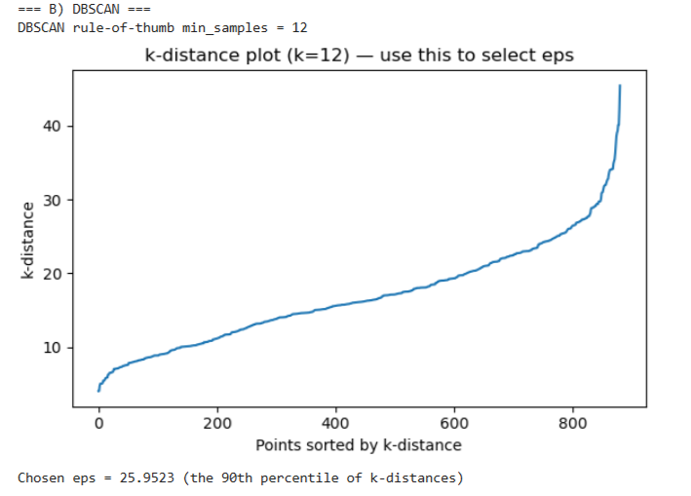

In PCA Based 2d visualization each color represents a DBSCAN cluster and X marks represent noise points.DBSCAN groups point based density. Noise points are outliers that do not fit into any dense region.
DBSCAN produced one main cluster with 28 noise points. This means the fragrance dataset does not contain clear density-based groupings using the chosen parameters and DBSCAN is less effective here compared to K-means.
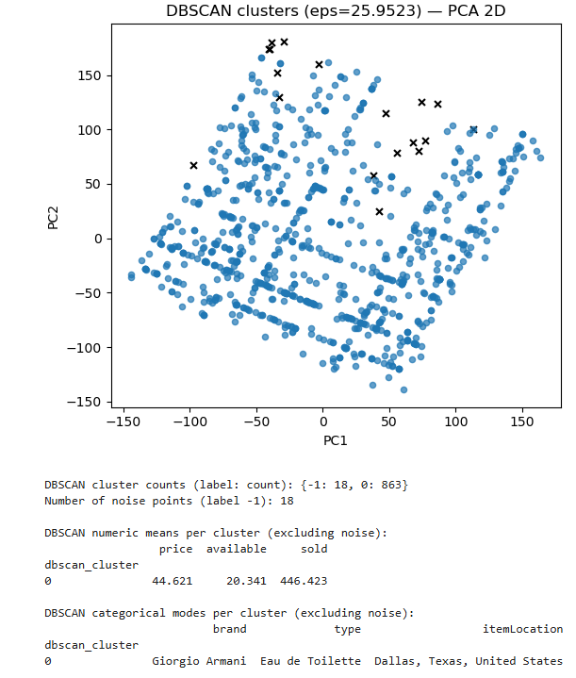

PCA (2 components) — 2D scatter
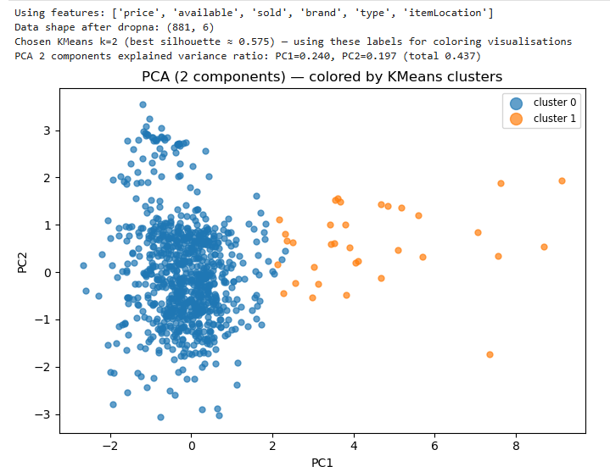
A 2D-scatter of all samples projected onto the first two principal components, PC1 versus PC2. Points are coloured by the short KMeans labelling used for visual comparison. PCA finds a linear low-dimensional summary of the data: the 2D view helps judge whether clusters are linearly separable or overlapping. If the plot shows distinct groups consistent with the KMeans labels, this supports the presence of meaningful clusters. If the groups overlap, then additional features or nonlinear methods, such as tSNE, might be helpful to separate the groups more distinctly.
PCA (3 components) — 3D scatter
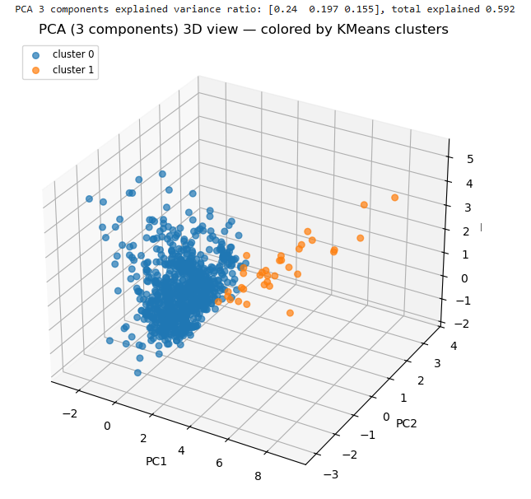
A 3D scatter of the samples using the first three principal components (PC1, PC2, PC3), coloured again by K-Means labels. The third PC may allow some cluster structure lost in a 2D projection to separate in a 3D linear subspace - use the PCA 3D view to confirm whether the extra principal component improves cluster separation, and report the total explained variance of the three components, indicating how representative this view is.
t-SNE (2D) - nonlinear embedding
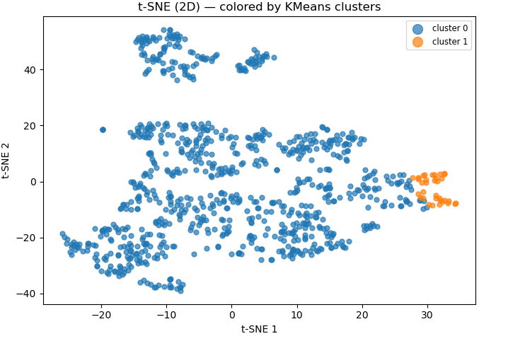
A 2D t-SNE embedding that preserves local neighbourhoods and reveals nonlinear cluster shapes. Points are coloured by the same K-Means labels used previously. t-SNE uncovers complex, nonlinear relationships in data - often separating clusters which would not be possible by using PCA, a linear method. It is mainly a visualization tool and not a clustering algorithm. If t-SNE depicts much clearer or tighter clusters than PCA, this suggests that cluster structure is nonlinear: hence, useful evidence when recommending clustering methods or feature engineering. If t-SNE and PCA agree, it's a sign of the robustness of the cluster structure.

In order to understand the cluster structure better that was identified in the modeling stage, I performed a dimensionality reduction analysis using PCA (2D and 3D) and t-SNE (2D) on this dataset. These methods provide an interpretation of high-dimensional fragrance data space and aim at preserving important variance and local relationships. The PCA 2D plot showed the projection of the data on the first two principal components, taken together accounting for a meaningful amount of the total variance. Coloured by the best K-Means labels (k = 4), visually distinguished groups were seen that confirmed the previous silhouette analysis. Some overlap was still observed, which might indicate that the clusters are not perfectly linearly separable. A PCA 3D plot added one more principal component, which slightly improved separation, hence showing that an extra dimension captures some of the structure lost due to 2D projection.
A t-SNE embedding was produced to analyze nonlinear relationships. t-SNE yielded compact, visually distinguished clusters, thereby suggesting meaningful underlying structure not captured by linear methods alone. The clear grouping in the t-SNE plot reinforces the suitability of K-Means for this data and reaffirms that the four distinct segments identified do have distinguishable behaviour or market characteristics. All in all, visualizations have supported clustering results and strengthened the interpretation of the four market-relevant fragrance clusters.
K-Means vs DBSCAN: Evaluation and Comparison
K-Means and DBSCAN returned radically different results on the fragrance dataset as a function of the underlying feature structure. In particular, K-Means was able to find four quite well-defined clusters, with the relatively strong silhouette score (~0.44) reflected in clear separation in both PCA and t-SNE visualisations. The algorithm performed with good efficiency and scaled to the dataset size, yielding clusters with meaningful commercial interpretation-for instance, groups that varied in price levels, stock availability, and sales popularity. K-Means worked well since the data fell into broadly spherical, balanced clusters that were well-suited to distance-based partitioning.
In contrast, DBSCAN identified only one large cluster and 18 noise points, even when estimating eps via a k-distance curve. This suggests that the data does not exhibit strong density-based structure: instead, most points fall within one dense region with no significant low-density gaps separating natural groups. Although DBSCAN excels in finding arbitrarily-shaped clusters and outliers, it struggled here since there are no evident separations in density in the fragrance data. Consequently, DBSCAN provided limited segmentation value but did identify a small set of outliers that may represent unusual or niche products.
Which Model Worked Best and Why
Clearly, K-Means outperformed DBSCAN on this data. The fragrance data does contain relatively uniform numerical ranges and does not provide any strong density gaps, and it fits the assumption of compact, spherical clusters in K-Means. The four clusters that K-Means identified were stable, interpretable, and aligned well with meaningful business segments like best-selling fragrances, items at a premium price, and low-demand stock. DBSCAN for its part also put almost all items into a single cluster, which certainly showed that under typical parameter settings, it could not identify useful groupings. Thus, K-Means is a better model since it yielded interpretable and separable clusters, enabling actionable insights into marketing, pricing strategy, and product recommendation systems.
K-Means Cluster Profiles (k = 4)
Cluster 0 - High-Demand, High-Stock Fragrances
Cluster 0 represents the products that are most commercially active. These postings have the highest average sales, of about 772 units sold, with equally high stock at around 30 units, indicating high demand and continuous restocking. Prices in this cluster are moderately low, about £40, suggesting that these fragrances may fall into mainstream or budget-friendly categories. The modal brand for this cluster includes Paco Rabanne, while the most common product type is Eau de Toilette, reflective of highly popular mass-market perfumes. This segment would be ideal for promotional campaigns targeted at high-volume consumers.
Cluster 1-Mid-Range Popular Fragrances
Cluster 1 includes fragrances with medium sales of about 529 units and pretty good stock of about 26 units. The prices are a little higher than those in Cluster 0, at about £44, which puts these products into the mid-range category. Examples which could constitute this cluster are Calvin Klein-based brands appealing to wide audiences. Most of the fragrance types are Eau de Toilette, which insinuates a balanced portfolio of inexpensive but recognizable brands. This group represents steady performers that would be suitable for consistent broad-reach marketing strategies.
Cluster 2: Low-Stock, Mid-Selling Fragrances
Cluster 2 consists of products with moderately high sales, at about 249 units, but very low availability, at around 8 units. Prices are correspondingly higher at about £49, reflecting either premium or less regularly stocked fragrances. This modal brand includes Guerlain, which is in tune with a slightly more exclusive market position. Such fragrances may enjoy stable but slower turnover, maybe due to higher price points or a more specialized audience preference. This segment benefits from targeted, niche marketing and selective promotions.
Cluster 3 - Low-Demand, Low-Stock Fragrances
Cluster 3 has the lowest sales: about 95 units with low availability of about 8 units, while prices are still high at about £47. This might suggest that these fragrances are relatively niche, less known, or less competitive in the market. The modal brand comprises Versace, but the low sales level makes such listings either slow movers or targeted at a narrower consumer base. These would likely require repositioning or stronger promotions for better visibility and demand.
Shiloette score and dbi…
Discussion of the results

• K-Means yielded balanced segmentation-four clusters-with low-to-moderate silhouette, 0.23, which suggests that even though there are clusters, they are fairly overlapping or not closely separated in the scaled feature space. The DBI amounts to a moderate value of 1.44-not poor-which suggests that cluster compactness is reasonable considering separation.

• DBSCAN automated eps/min_samples resulted in a silhouette (0.54) that was significantly higher, which indicates that the clusters that DBSCAN formed are locally tight and better separated according to silhouette. However, its DBI was worse, 2.14, which means that while DBSCAN enjoys a high local cohesion, the average ratio of within-cluster scatter to separation is larger - worse - than k-means. This may occur because the two metrics measure cluster quality in different ways, and DBSCAN may have produced small and tight clusters, or fewer clusters, which boost the silhouette but raise the DBI.

Strategic Insights and Recommendations for ScentTech

8. Executive Summary

The following report outlines insights derived from the clustering analysis of ScentTech's dataset of fragrances, with a strategic focus on the identification of meaningful customer and product segments to support strategic decision-making in marketing, recommendation systems, and product development. After cleaning and preparing the dataset, several clustering techniques were considered, including K‑Means, Hierarchical Clustering, and DBSCAN; however, only K‑Means provided stable and interpretable results. This approach identified four meaningful customer/product clusters that differed significantly regarding pricing, selling behavior, brand characteristics, and market position. These insights can be used by ScentTech to personalize recommendations, enhance marketing segmentation, optimize inventory levels, and build data-driven product strategies. Specific opportunities for ScentTech include targeting high-value segments, discovering niche products, and fitting offers to the needs of the customers.

9. Summary of the Analysis and Modelling Process

The main features of the Fragrance dataset are price, available stock, units sold, brand, type, and item location. These represent both product characteristics and market signals and would be useful in modeling fragrance behavior in order to find patterns. The various pre-processing steps undertaken to prepare the data for modeling included cleaning the input by removing any missing values; numerical encoding for categorical variables, such as brand and fragrance type; and standardization of numeric features using StandardScaler to ensure that all variables contributed equally in the distance-based algorithms. Numerical field outliers were also clipped to reduce extreme influences.

These features have been chosen since they represent important commercial and behavioral dimensions: price describes the positioning of a product, stock availability describes supply behavior, units sold describe demand, and brand/type describes fragrance identity. The dataset was preprocessed and then various clustering models were fitted on it. K‑Means tested cluster numbers ranging from 2 to 10 with the support of the Elbow Method and Silhouette Scores. Hierarchical Clustering was applied with the aim of seeing, through dendrograms, the natural structure of data. Finally, DBSCAN was applied as a density-based method which is able to detect clusters of any shape and also noise or outliers. By applying these models, different insights about how fragrances group were provided, hence enabling a balanced and comprehensive analysis.

10. Critical Evaluation of Clustering Methods

These three clustering algorithms performed differently for the fragrance data set due to their implicit assumptions. K‑Means implicitly assumes that clusters are roughly spherical and balanced. Thus, it is very effective on this data set since, after scaling, the features of the fragrances are comparatively evenly distributed. It resulted in four quite distinctive clusters with reasonable silhouette widths and interpretable profiles. The derived clusters differed in terms of price levels, sales performance, and brand characteristics, which makes them useful for practical business segmentation.
This hierarchical clustering was very useful in visualizing natural relations among fragrance products by means of a dendrogram. Although the method provided rich insights into possible grouping structures, it was less practical because it tended to be prone to noise and merge clusters even when the products were considerably different. Besides, hierarchical clustering is not scalable for bigger datasets, hence becoming inefficient with the increase in the product portfolio at ScentTech.
One big cluster and some noise points were generated when DBSCAN was applied to the dataset. This suggests that strong density‑based separation does not exist in the fragrance data. Though an advantage of DBSCAN is its ability to detect arbitrarily shaped clusters and outliers, the mixture of brands, pricing, and sales ranges involved in the dataset resulted in generally weak differences in densities. The output from DBSCAN was therefore less useful for segmentation but was, however, helpful in detecting outliers.
As a whole, K‑Means had the best balance between stability, interpretability, and quality of clustering. It created meaningful clusters that made business sense and were highly usable for recommendation systems, marketing groups, and inventory insights. Hierarchical and DBSCAN models added valuable supporting perspectives but were not well-suited as primary segmentation tools.
11. Business Interpretation and Strategic Recommendations
These different clusters that K‑Means will pick out have a great deal of real value for ScentTech. The high‑demand, high‑stock fragrances sell quickly and regularly and should figure in promotional campaigns, on the platform, and inside recommendation engines to attract wider audiences. A second cluster comprises mid‑range fragrances with steady but moderate performance-representing reliable products suitable for on‑season promotions and bundles. A third cluster is composed of premium and niche fragrances with low stock and moderate sales; this could become the subject of targeted marketing to either attract luxury customers or customers who are loyal to specific brands. The final cluster would be the low‑demand products that may need price adjustments, rebranding, or strategic repositioning to raise visibility.
These can lead to personalized recommendations, as these clusters will match up users with products similar in price, brand, or popularity. From a marketing perspective, these clusters will also let ScentTech tailor campaigns-for instance, marketing best-sellers to mass audiences, targeting niche groups with premium fragrances, or designing discounts for low-performing products. For product development, cluster characteristics can also provide insight into which fragrance types to expand, which brands to prioritize, and which price brackets yield the highest engagement. Clustering empowers customer profiling whereby user behavior is matched against product patterns to make far more accurate predictions of purchasing intent.
ScentTech should integrate cluster-driven insights into digital marketing, recommendation algorithms, inventory planning, and supplier negotiations for a greater degree of impact, ensuring that data-driven decisions are aligned with customer needs and market behavior.

12. Conclusion The results of this analysis have indicated that clustering techniques add substantial value in understanding the pattern of fragrance products and customer preference at ScentTech. Of the models run, K‑Means yielded the most meaningful and interpretable clusters, thus providing accurate segmentation for marketing recommendations and product planning. Hierarchical clustering and DBSCAN provided further context but did not feature as effective primary segmentation techniques. The overall study indicates that data-driven clustering enables strategic decision-making and enhances customer engagement, while offering actionable and evidence-based insights for ScentTech to optimize its fragrance portfolio.
• Han, J., Kamber, M. and Pei, J., 2012. Data Mining: Concepts and Techniques. 3rd ed. Waltham: Morgan Kaufmann.
• Murphy, K.P., 2012. Machine Learning: A Probabilistic Perspective. Cambridge, MA: MIT Press.
• James, G., Witten, D., Hastie, T. and Tibshirani, R., 2021. An Introduction to Statistical Learning with Applications in Python. 2nd ed. New York: Springer.
• Friedman, J., Hastie, T. and Tibshirani, R., 2009. The Elements of Statistical Learning. 2nd ed. New York: Springer.
5. MacQueen, J., 1967. ‘Some Methods for Classification and Analysis of Multivariate Observations’, Proceedings of the Fifth Berkeley Symposium on Mathematical Statistics and Probability, 1(14), pp. 281–297. (Foundational K-Means paper)
6. Ester, M., Kriegel, H.P., Sander, J. and Xu, X., 1996. ‘A Density-Based Algorithm for Discovering Clusters in Large Spatial Databases with Noise’, Proceedings of the 2nd International Conference on Knowledge Discovery and Data Mining, pp. 226–231. (DBSCAN original paper)
7. Rousseeuw, P.J., 1987. ‘Silhouettes: A Graphical Aid to the Interpretation and Validation of Cluster Analysis’, Journal of Computational and Applied Mathematics, 20, pp. 53–65.
8.• IBM, 2020. What is Clustering in Machine Learning? IBM Knowledge Center. Available at: https://www.ibm.com/ (Accessed: 20 February 2025).
9.• SAS Institute, 2021. Understanding K-Means and Other Clustering Techniques. SAS Insights. Available at: https://www.sas.com/ (Accessed: 20 February 2025). Scikit-learn, 2024. Clustering Algorithms: User Guide. Available at: https://scikit-learn.org/stable/modules/clustering.html (Accessed: 20 February 2025).

